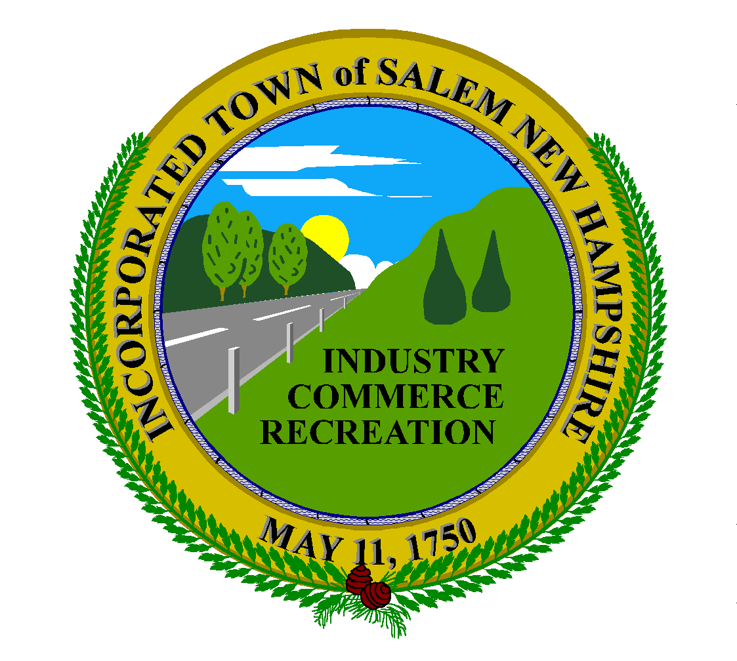
Town of Salem, New Hampshire
Salem Purchasing
33 Geremonty Drive
Salem, New Hampshire 03079
(603) 890-2090 fax (603) 890-2091
Gia Faccadio
Purchasing Agent

- Bid Number: 2021 - 030 Bid Results:

- Project: Northwestern/Bannister Reconstruction

- Bid Closing: January 18, 2022 @ 1:00pm

Contractor  Vendor | Bid Bond  Provided | Statement Quals | Non  Collusion | Addendum #1 | Schedule A | Schedule B | TOTAL  BID PRICE
E.J. Paving | Y | Y | Y | Y | $ 1,300,885.57 | $ 307,555.00 | $ 1,608,435.57
Busby Construction | Y | Y | Y | Y | $ 1,500,642.00 | $ 294,955.00 | $ 1,795,597.00
Jennings Excavation | Y | Y | Y | Y | $ 1,877,081.60 | $ 319,841.00 | $ 2,196,922.60

